**MODULE: 13 React – Applying Redux**

**Q1- What is Redux?**

**Ans-** Redux is a state management library for JavaScript applications, commonly used with React. It helps manage the state of your application in a predictable way, by keeping all the application state in a single immutable object called the "store".

Actions are dispatched to the store, and reducers handle these actions to update the state. Redux provides a central place to manage state, making it easier to debug, test, and scale your application.

**Q2- What is Redux Thunk used for?**

**Ans-** Redux Thunk is a middleware for Redux that allows you to write action creators that return functions instead of plain objects. This is useful for handling asynchronous logic, such as making API calls, in Redux actions. With Redux Thunk, you can delay the dispatch of an action, or dispatch multiple actions based on the result of asynchronous operations.

**Q3- What is Pure Component? When to use Pure Component over Component?**

**Ans-** In React, a Pure Component is a class component that extends React.PureComponent instead of React.Component.

Pure Components perform a shallow comparison of their props and state to determine if they should update. If the props and state have not changed, a Pure Component will not re-render, improving performance by avoiding unnecessary updates.

Use Pure Components when you know the component's render output is solely dependent on its props and state, and there are no side effects in its lifecycle methods.

**Q4- What is the second argument that can optionally be passed tosetState and what is its purpose?**

Ans- In React's setState method, you can pass an optional second argument, which is a callback function that gets executed after the state has been updated and the component has re-rendered. This callback function is typically used for performing additional actions or side effects that depend on the updated state. It's useful for scenarios where you need to execute code after the component has updated its state, such as triggering animations, making API calls, or updating other parts of the application.

**Q5- Create a Table and Search data from table using React Js?**

**Ans-** [**https://github.com/shivani6137/reacttablesearch**](https://github.com/shivani6137/reacttablesearch)

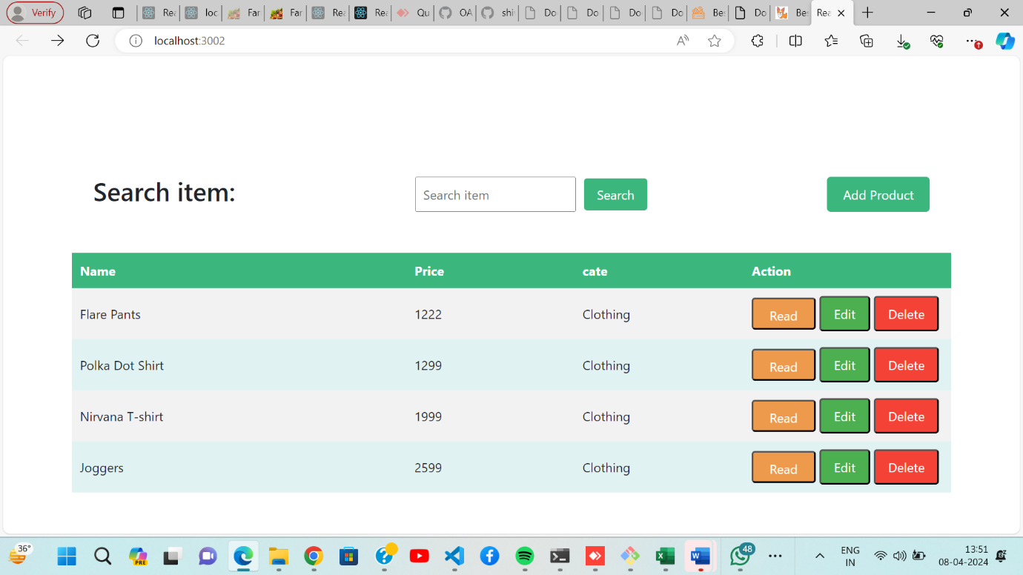

**Q6- Create Login registration with CRUD Application using API (Redux)**

**Ans-** [**https://github.com/shivani6137/assigncrud**](https://github.com/shivani6137/assigncrud)